Securing from unauthorized access
Centralized Identity and Access Management
Google use OAuth2 framework, all login and signup separated into one component. They use auth server. It is open authorization. Regardless what type of communication, there is grant flow. It issues access tokens to user depending on business framework.
Jargons:
Resource owner, end user
Client: StackoverFlow as a client to login via github on stack over flow
Authorization Server: A server having my account like on GITHUB server
Resource Server: Token given by authorization, client will use to access the resourced like profile name, location etc.
Scope: Based on privileges, to what extent access they will use

OpenID connect and why it is important?
OAuth2 good for authorization. Auth server will send this token, if we use it. It is wrapper on the top of OAuth 2.0. So, in order to follow a standard. It also has endpoints that user can use to get information about logged in user. ID token is using JWT standard. IAM using Open ID token. We have like Key Cloak who provides authentication and authorization server free to us as open source, Okta is also available for IDM, Amazon Cognito, also ForgeRock. Spring also spring authorization server where we can build our own authorization server.

Gateway as resource server, proper access token. We will protect our microservices from hackers by using all microservices behind a firewall or on a same network so that hacker or third party has to go through edge/resource/gateway server.
docker run -p 7080:8080 -e KEYCLOAK_ADMIN=admin -e KEYCLOAK_ADMIN_PASSWORD=admin quay.io/keycloak/keycloak:22.0.3 start-dev

Realm is like environment in KeyCloak auth server. It works atleast java 17.

Created a user on KEYCLOAK with client etc details. Using public certificate it verifies that token is generated from key cloak server.
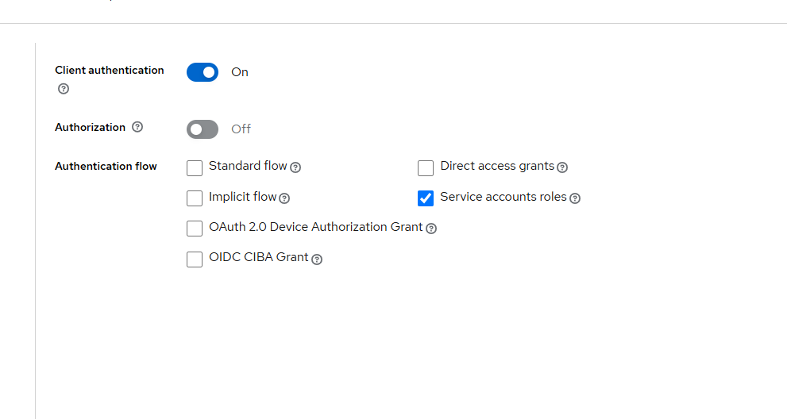

Two steps are adopted like client id then using credentials to access the token and then using it to access the resources.
http://localhost:7080/admin/master/console/#/master/clients/0fe553b5-9324-4609-aff8-2a1c9d754ae3/credentials
https://www.udemy.com/course/master-microservices-with-spring-docker-kubernetes/learn/lecture/39945540#reviews
https://www.oauth.com/playground
Separate clients for authentication and client credentials

At Last:
Security done as accounts, cards, loans will not now run on local ports as only gateway server is exposed to outside world only

